Lab 9

Objectives:
To learn and understand the working of Half Adder, Full Adder and Latches
Adder and subtractor
Half Adder:
Half adder is a logic circuit that performs binary addition of two 1-bit numbers. It generates two outputs namely ‘Sum’ and ‘Carry’.
Truth Table:
A | B | Carry | Sum
0 | 0 | 0 | 0
0 | 1 | 0 | 1
1 | 0 | 0 | 1
1 | 1 | 1 | 0

Boolean Expressions of Outputs:

$Sum=A⊕B$
$Carry=AB$

Half Subtractor:
Half subtractor is a logic circuit that performs binary subtraction of two 1-bit numbers. It generates two outputs namely ‘Difference’ and ‘Borrow’.
Truth Table:
A | B | Borrow | Difference
0 | 0 | 0 | 0
0 | 1 | 1 | 1
1 | 0 | 0 | 1
1 | 1 | 0 | 0

Boolean Expressions of Outputs:

$Difference=A⊕B$
$Borrow= \overline{A}B$

Full Adder:
Full adder is a logic circuit that performs binary addition of two 2-bit numbers. It generates two outputs namely ‘Sum’ and ‘Carry’.

Truth Table:
A | B | C | Carry | Sum
0 | 0 | 0 | 0 | 0
0 | 0 | 1 | 0 | 1
0 | 1 | 0 | 0 | 1
0 | 1 | 1 | 1 | 0
1 | 0 | 0 | 0 | 1
1 | 0 | 1 | 1 | 0
1 | 1 | 0 | 1 | 0
1 | 1 | 1 | 1 | 1

Boolean Expressions of Outputs:

$Sum=A⊕B⊕C$
$Carry= AB+BC+AC$or$Carry= AB+C(A⊕B)$

Full Subtractor:
Full subtractor is a logic circuit that performs binary subtraction of two 2-bit numbers. It generates two outputs namely ‘Difference’ and ‘Borrow’.
Truth Table:

A | B | C | Borrow | Difference
0 | 0 | 0 | 0 | 0
0 | 0 | 1 | 1 | 1
0 | 1 | 0 | 1 | 1
0 | 1 | 1 | 1 | 0
1 | 0 | 0 | 0 | 1
1 | 0 | 1 | 0 | 0
1 | 1 | 0 | 0 | 0
1 | 1 | 1 | 1 | 1

Boolean Expressions of Outputs:

$Difference=A⊕B⊕C$
$Borrow= \overline{A}B+BC+\overline{A}C$or$Carry= \overline{A}B+C(\overline{A}⊕B)$

Lab Tasks:
Question 1
Implement an SR latch on Logic Trainer and Logic Works with control input as follows:
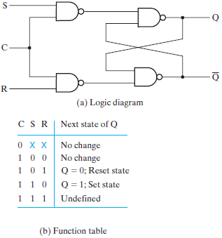
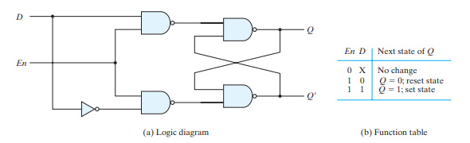
Question 2:
Implement 2 bit by 2 bit multiplier cirucit on the Logic Trainer and Logic Works.
Question 3
Implement the full adder circuit on Logic Trainer and Logic Works.

